Common Core Standards and Special Education

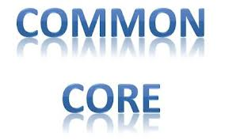
CESA 12 Conference Center

October 24, 2012

Registration: 8:30 – 9:00 AM

Training: 9:00 AM – 3:30 PM

Overview

This training introduces special education teachers to the common core standards and discusses how their curriculum is impacted by the change in standards. Teachers will analyze grade level expectations and learn about the impact on their curriculum and the instructional methods used in their department. Educators will also be introduced to the new alternate assessment test, essential elements, and smarter balanced assessment.

Presenter

Amanda Popovich, Curriculum Coordinator, CESA 12

Wisconsin State Performance Plan Indicators & Standards Addressed

Wisconsin's State Performance Plan Indicators: 1, 2, 3, and 9
Wisconsin Teacher Standards Addressed: 1, 2, 3, 4, 6, and 7
Wisconsin Pupil Services Standards Addressed: 1 and 7
Wisconsin Administrator Standards Addressed: 1, 2, 3 and 6

Target Audience
K-12 Special Education Teachers
Pupil Service Directors
Special Education Directors
School Psychologists
Principals

Registration Fee: This training is FREE to Central EEN Leadership Consortium Districts: Ashland, Bayfield, Butternut, Chequamegon, Drummond, Hayward, Hurley, Maple, Mellen, Mercer, Northwood, Phillips, Solon Springs, South Shore, Superior, and Washburn.

Fee for Non Consoritum Districts - $125 per participant:
(Winter School District and other organizations)

Registration fee includes materials, break and lunch

Registration Deadline:
October 19, 2012
(Registrations cancelled after registration deadline will not be refunded)

Viterbo Credit Available
Please register by going to: www.myquickreg.com

